Project Planning Phase
Project Planning Template (Product Backlog, Sprint Planning, Stories, Story points)

Date | 1 October 2026
Team ID | SWTID-2026-5148
Project Name | Implement Client Script & UI Policy (Incident)
Maximum Marks | 5 Marks
Team: Mathangi S (Team Leader), Meena Varshini T P, Mirthika R, Muthu Priya U | Team ID: SWTID-2026-5148 | Team Size: 4
Product Backlog, Sprint Schedule, and Estimation (4 Marks)
Use the below template to create product backlog and sprint schedule
Sprint | Functional Requirement (Epic) | User Story Number | User Story / Task | Story Points | Priority | Team Members
Sprint-1 | Incident Creation & Impact Handling | USN-1 | As a service desk agent, I can set the Impact of an Incident to High so that the system applies the extra controls for serious incidents. | 1 | High | Mathangi S
Sprint-1 |  | USN-2 | As a service desk agent, I must provide the Assignment group when Impact is High so that the incident is routed to the right team. | 2 | High | Mathangi S
Sprint-1 |  | USN-3 | As a service desk agent, I want Urgency to be set automatically to High when Impact is High so that priority stays consistent. | 2 | High | Mirthika R
Sprint-1 |  | USN-4 | As a service desk agent, I want Urgency to be read-only while Impact is High so that it cannot be set to a mismatched value. | 2 | Medium | Meena Varshini T P
Sprint-1 | Configuration | USN-11 | As an administrator, I can create and activate the UI Policy and its actions on the Incident table so that conditional field behaviour is enforced. | 3 | High | Mathangi S, Meena Varshini T P
Sprint-1 |  | USN-12 | As an administrator, I can create onChange, onSubmit and onCellEdit Client Scripts on the Incident table so that data is validated in the browser. | 3 | High | Mirthika R
Sprint-2 | Save Validation | USN-5 | As a service desk agent, I am prevented from saving a High-impact Incident without Assigned To so that no serious incident is left unowned. | 3 | High | Mirthika R
Sprint-2 |  | USN-6 | As a service desk agent, I can save the Incident once Assigned To is filled so that valid records are submitted without errors. | 1 | High | Muthu Priya U
Sprint-2 | Reverse Behaviour | USN-7 | As a service desk agent, when I change Impact from High to Medium, I want the extra controls removed so that I can work normally. | 2 | Medium | Meena Varshini T P
Sprint-2 | State Update | USN-8 | As a service desk agent, I can change the State of an Incident on the Incident form so that I can move it through its lifecycle. | 1 | High | Muthu Priya U
Sprint-2 | Data Quality & Control | USN-9 | As an ITSM manager, I want State changes from the list view to be blocked so that status updates follow the validated form rules. | 3 | High | Mirthika R
Sprint-3 |  | USN-10 | As an ITSM manager, I want every High-impact incident to have an assignee and group so that reports and SLAs are accurate. | 2 | Medium | Mathangi S
Sprint-3 | Testing | USN-13 | As an administrator, I can run the test activities so that I can confirm all configured behaviours work as expected. | 3 | Medium | Muthu Priya U, Mathangi S
Sprint-3 | Incident Submission | USN-14 | As a caller, I want my high-impact issue to reach the support team with complete details so that it is handled quickly. | 2 | Medium | Meena Varshini T P

Project Tracker, Velocity & Burndown Chart: (4 Marks)
Sprint | Total Story Points | Duration | Sprint Start Date | Sprint End Date (Planned) | Story Points Completed (as on Planned End Date) | Sprint Release Date (Actual)
Sprint-1 | 13 | 6 Days | 05 Oct 2026 | 10 Oct 2026
Sprint-2 | 10 | 6 Days | 12 Oct 2026 | 17 Oct 2026
Sprint-3 | 7 | 6 Days | 19 Oct 2026 | 24 Oct 2026

Velocity:
Our sprint duration is 6 days. Total story points are 30 over 3 sprints (13 + 10 + 7), so the team velocity is 30 / 3 = 10 story points per sprint. The average velocity (AV) per iteration unit (story points per day) is calculated below.
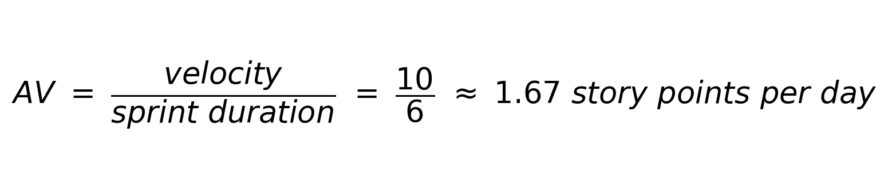

Burndown Chart:
A burn down chart is a graphical representation of work left to do versus time. It is often used in agile software development methodologies such as Scrum. However, burn down charts can be applied to any project containing measurable progress over time.
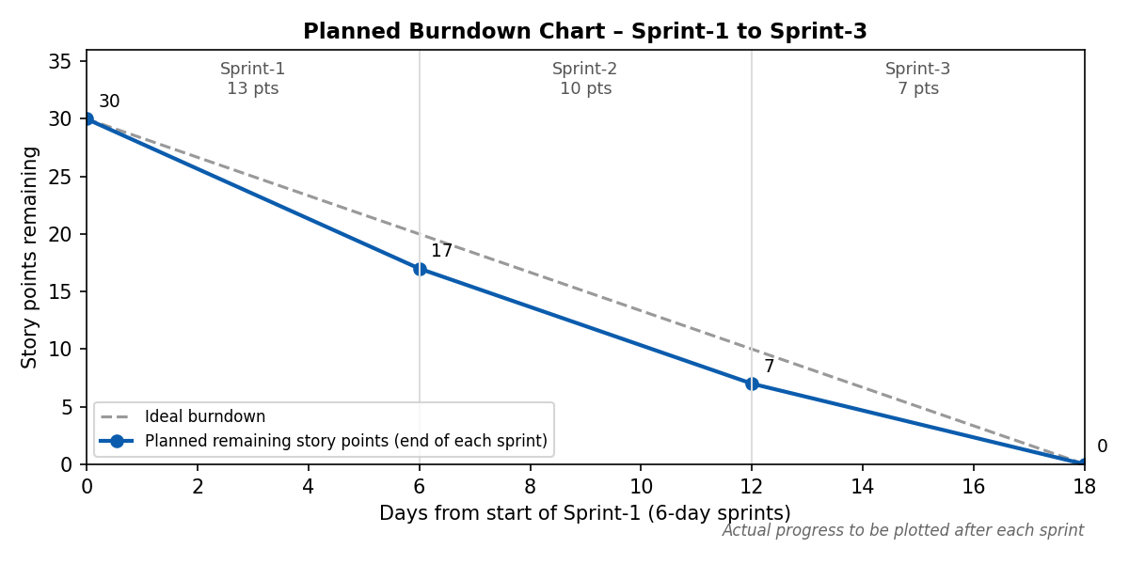
Note: Story Points Completed and Sprint Release Date (Actual) will be filled in as each sprint finishes. Sprint dates are planned dates.

https://www.visual-paradigm.com/scrum/scrum-burndown-chart/
https://www.atlassian.com/agile/tutorials/burndown-charts

Reference:
https://www.atlassian.com/agile/project-management
https://www.atlassian.com/agile/tutorials/how-to-do-scrum-with-jira-software
https://www.atlassian.com/agile/tutorials/epics
https://www.atlassian.com/agile/tutorials/sprints
https://www.atlassian.com/agile/project-management/estimation
https://www.atlassian.com/agile/tutorials/burndown-charts

